BUILDNG A BLOG APP:

Offered by **Smart Internz**



**TEAM ID:** LTVIP2023TMID08233

Kusumanchi Swathi(20NM1A0486)-Team Leader

Matcha Geetha Sai (20NM1A04A4)

Kattamuri Sreya Sri (20NM1A0476)

Gummadi Vasanthi (20NM1A0467)

**INTRODUCTION:**

A blogging app is a digital tool that you can use to run your blog. Some apps allow you to write your blog posts. other apps are better for storing content, like photos, editing photos, or collaborating with other writers for your blog. Blogging apps are important because they can help you be more productive. When [starting a blog](https://bloggingtips.com/how-to-start-a-blog/), you only have so much time to write the posts and organize all of your content. Apps come in very handy for beginners and experienced bloggers.

**PROJECT DESCRIPTION:**

The blog app is a web application that provides real-time blog posts. Based on products, Solutions, New technologies, New projects, and Management. The blog app is fully responsive. The blog is made using Java script, CSS, HTML,and Bootstraps. The central theme of the blog is to show new ideas and new innovations on one website.

**TECHNICAL ARCHITECTURE:**

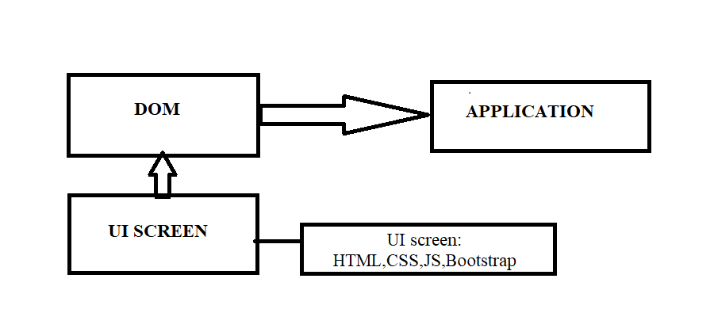 **PROJECT OBJECTIVE:**

By the end of this project, we will be able to:

* Create a user-friendly interface using HTML and CSS to display blog posts.

**PROJECT FLOW:**

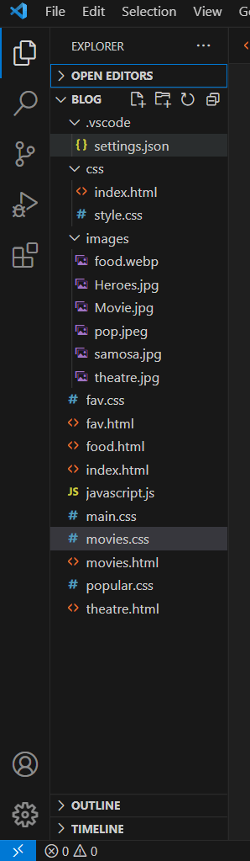

**PROJECT STRUCTURE:**

The structure of a BLOG APP involves several components that work together to provide users with real-time information. Below is an outline of the key components and their functionalities:

1. User Interface (UI):

* **Input Field**: Allows users to enter the name of the movies they want to check the popularity for.
* **Search Button**: Triggers the data retrieval process when clicked.
* **Information Section**: Displays the retrieved data, including movies, Heroes, Food, etc.

1. HTML File (index.html):

* Contains the basic structure of the app's user interface.
* Includes references to the CSS and JavaScript files.

The below Fig 1. Shows the html code used to create the blog app

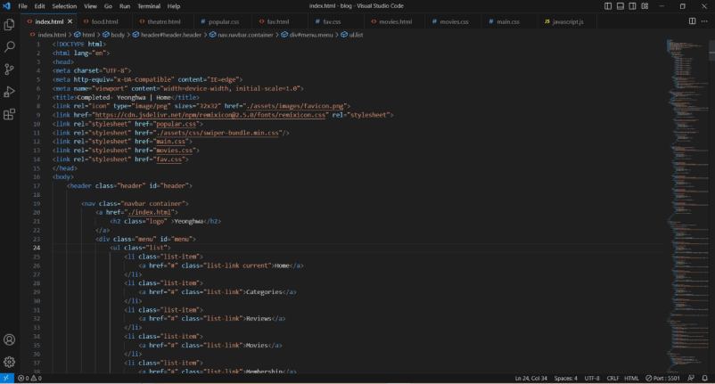

Fig 1. HTML Code

3. CSS File (styles.css):

* Defines the styling and layout of the user interface.
* Formats fonts, colors, backgrounds, buttons, and input fields.

The below fig shows the CSS code i.e., is used to create the blog app

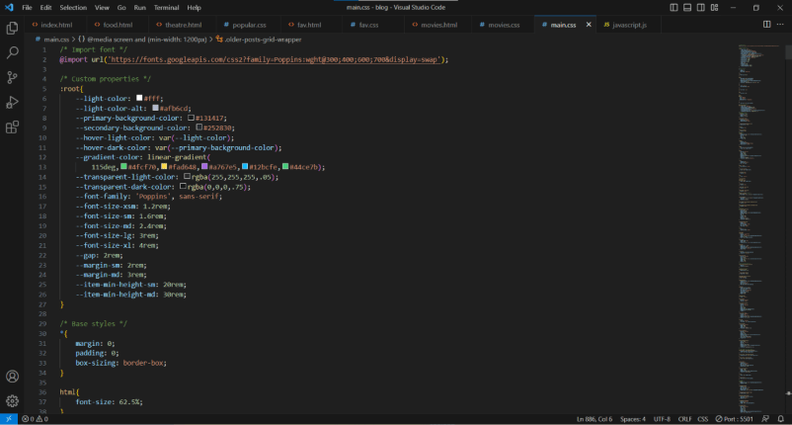

Fig 2. CSS code

4. JavaScript File (script.js):

* Implements the functionality of the app, handling user interactions and data retrieval.
* Contains event listeners to capture user actions, such as clicking the search button.

The Fig 3. shows the java script code used to create the blog app

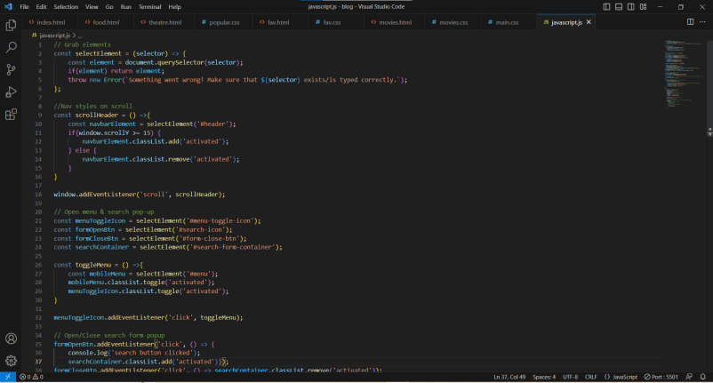

Fig 3. JS Code

**The interaction flow of the blog app can be summarized as follows:**

1. The main Theme of our blog app is Yeonghwa(Movies).

2.User enters the name of a movie into the input field.

2. User clicks the search button to initiate the movie related data retrieval process.

3. By clicking on movies logo user can get the latest updates of the movies.

4. Similarly user can get the details related to movies like Popular Heroes and food at theatres.

5. Our Blog also contains Older posts, popular tags and also user can subscribe by giving their email address to get latest updates.

6. The app updates the information section on the user interface with the fetched data.

**PROJECT OUTCOME:**

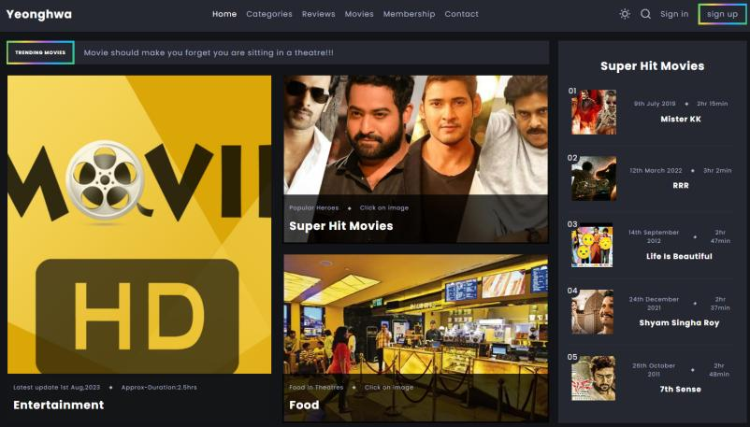

Fig 4.1: Main Page of our Blog

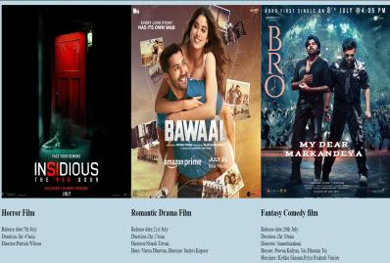 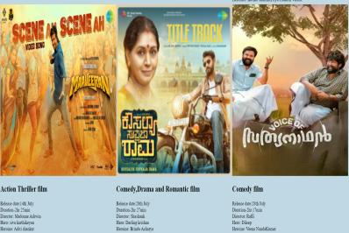

Fig 4.2: Latest Updates of Movies

 

Fig 4.3: Popular Heroes and their Hit Movies

 

Fig 4.3: Food at Theatres

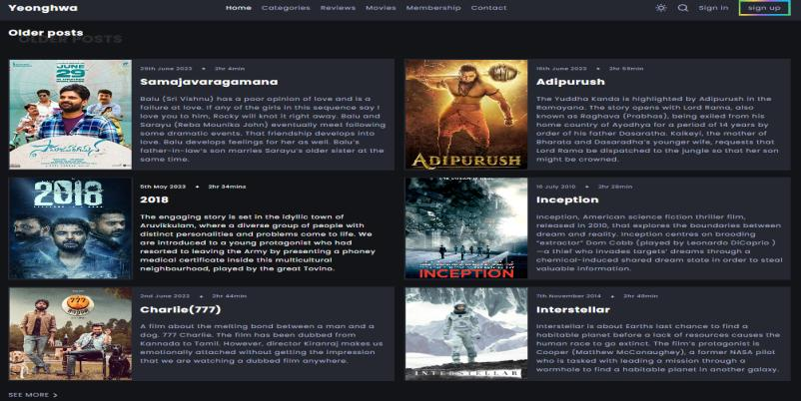

Fig 4.4: Older Posts

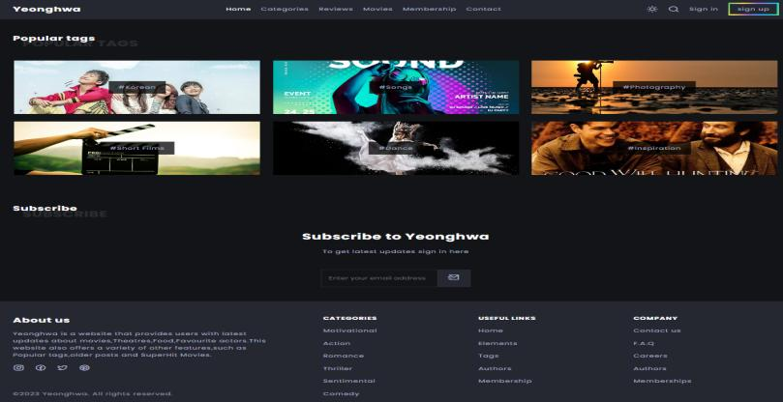

Fig 4.5: Popular Tags and Subscription

**Conclusion:**

The Blog App is a web application that provides real-time information and updates of new technologies: products, and solutions to the users. The project's modular structure allows for easy-to-read the post. The project features additional UI and a responsive search bar and that card should show the details.

**GitHubLink**:<https://github.com/swathikusumanchi02/Building-a-Blog-App/tree/main/project/>